Installation of Arduino driver
First time you connect Arduino to you computer, below interface will pop up:
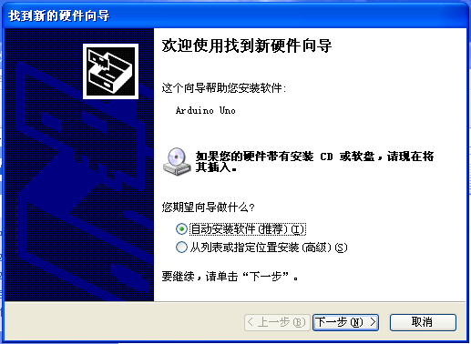
Select option 2 “install from a list or specified location”, and click “next”
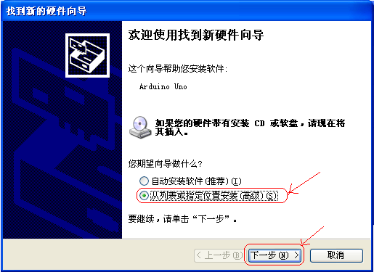
Find the driver folder from Arduino installation folder, click next
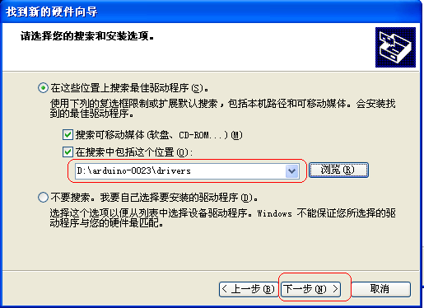
Click “done”
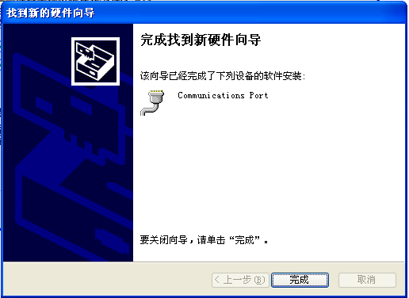
The driver is now installed. Move your mouse to “my computer”, right-click “device or device manager”
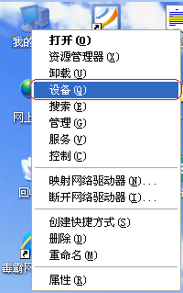
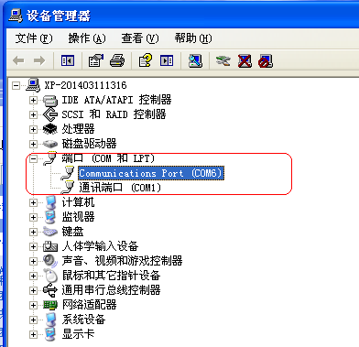
No exclamatory mark means driver is successfully installed.
Thank you!

